Title of Paper
First A. Author and Second B. Author Jr.
Business or Academic Affiliation’s Full Name 1, City, State, Zip Code, Country
Third C. Author
Business or Academic Affiliation’s Full Name 2, City, Province, Zip Code, Country
Fourth D. Author
Business or Academic Affiliation’s Full Name 3, City, State, Zip Code, Country
Please insert your abstract text here. These instructions give you guidelines for preparing an abstract for the ASCEND Call for Papers. Use this document as a template if you are using Microsoft Word, otherwise, use this document as an instruction set. The footnote on the first page should list the Job Title and AIAA Member Grade for each author, if known. Authors do not have to be AIAA members.
- Instructions
This document is a template for Microsoft Word. If you are reading a hard-copy or pdf version of this document, you may download the Word version at https://www.ascend.events/call-for-content/submission-guide.
All abstracts must be submitted through the ScholarOne submission site, which can be accessed through the Call for Papers webpage at https://www.ascend.events/call-for-content/call-for-papers/.
To create your formatted abstract, simply type your own text or cut and paste from another document over the entries, above. Note that special formatting such as subscripts, superscripts, and italics may be lost when you copy your text into the template.
Requirements:
- Your abstract must include sufficient detail to demonstrate the purpose of the paper, the intellectual foundation for the topics to be discussed, any preliminary results to date, and the expected results of the final paper. Sufficient information must be included in the submission to convince the conference organizers and reviewers that the author(s) will have a strong likelihood of completing the final paper by the final paper submission deadline.
- Your abstract text should contain a minimum of 1000 words. Submissions that fall outside of these parameters may be rejected at the discretion of the Topic Administrator.
- You may include supporting materials, including key figures, equations, tables, or a list of references in the body of this document, below.
- After you complete your abstract, please delete these instructions before submitting.
- Optional Supporting Materials
Please use this section to include any supporting materials, such as figures, equations, tables, or references. Materials included in this section will not impact the abstract word-count requirement. You may delete this section, or any unused subsection within it, if you are not including supporting materials.
- Images, Figures, and Tables
All supporting figures, graphs, and tables may be placed in this subsection as shown in the example (Fig. 1). Please delete this subsection if you are not including any such items.

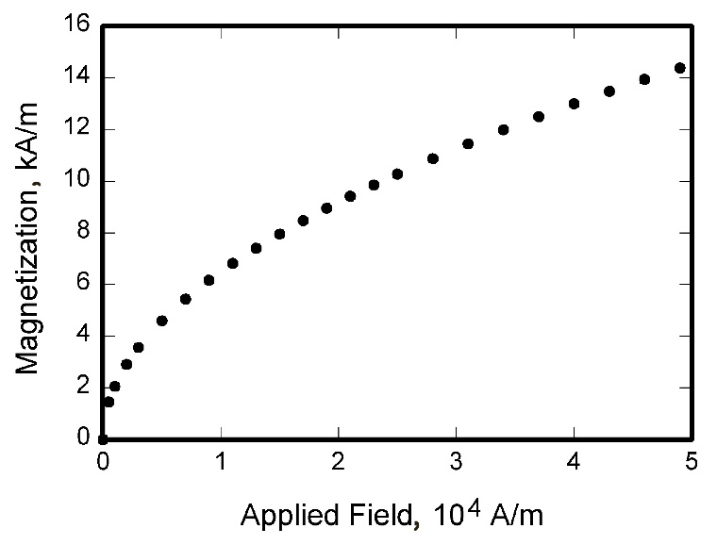
Fig. 1 Magnetization as a function of applied fields.
- References
References are not required but may be included here as a numbered list as shown in the examples. Please delete this subsection if you are not including any references.

- Dornheim, M. A., “Planetary Flight Surge Faces Budget Realities,” Aviation Week and Space Technology, Vol. 145, No. 24, 9 Dec. 1996, pp. 44–46.
- Peyret, R., and Taylor, T. D., Computational Methods in Fluid Flow, 2nd ed., Springer-Verlag, New York, 1983, Chaps. 7, 14.
- Chi, Y. (ed.), Fluid Mechanics Proceedings, NASA SP-255, 1993.
- Atkins, C. P., and Scantelbury, J. D., “The Activity Coefficient of Sodium Chloride in a Simulated Pore Solution Environment,” Journal of Corrosion Science and Engineering [online journal], Vol. 1, No. 1, Paper 2, URL: http://www.cp/umist.ac.uk/JCSE/vol1/vol1.html [retrieved 13 April 2020].

Revised March 2022

Insert Job Title, Department Name, and AIAA Member Grade (if any) for first author.
Insert Job Title, Department Name, and AIAA Member Grade (if any) for second author.
Insert Job Title, Department Name, and AIAA Member Grade (if any) for third author.
Insert Job Title, Department Name, and AIAA Member Grade (if any) for fourth author (etc.).

